- Tên và phân loại:

- Mục đích, ý nghĩa:
- Compose objects into tree structures to represent part-whole hierarchies
- Composite lets clients treat individual objects and compositions of objects uniformly
- Động lực sử dụng:
Consider a graphics application. A Graphic can be:
• A Line
• A Rectangle
• A Text Box
• Any combination of them
• etc
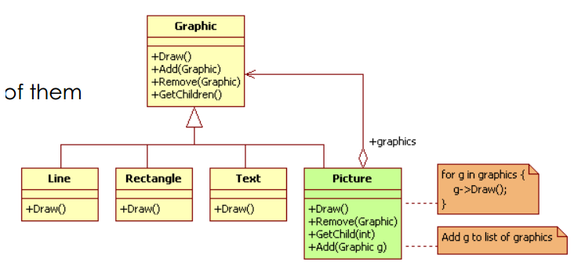
- Khi nào sử dụng:
▪- You want to represent part-whole hierarchies of objects
▪ - You want clients to be able to ignore the difference between compositions of objects and individual objects. Clients will treat all objects in the composite structure uniformly.

- Cấu trúc
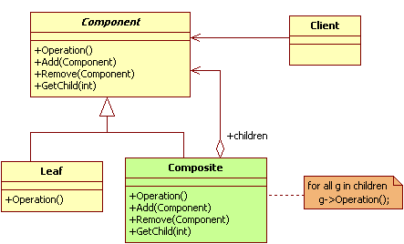

- Các thành viên - Sự cộng tác
▪ Component:
• Declares the interface for objects in the composition
• Implements default behavior for the interface common to all classes, as
appropriate
• Declares an interface for accessing and managing its child components
• Defines an interface for accessing a component's parent in the recursive
structure, and implements it if that's appropriate (optional)
▪ Leaf:
• Represents leaf objects in the composition
• Has no children
• Defines behavior for primitive objects in the composition
▪ Composite:
• Defines behavior for components having children
• Stores child components
• Implements child-related operations in the Component interface
▪ Client:
• Manipulates objects in the composition through the Component interface
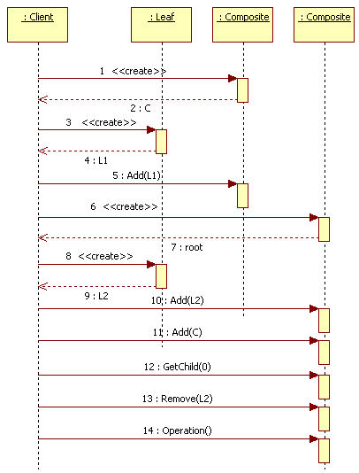
- Các hệ quả mang lại:
- Defines class hierarchies consisting of primitive objects and composite objects. Primitive objects can be composed into more complex objects, which in turn can be composed, and so on recursively. Wherever client code expects a primitive object, it can also take a composite object.
- Makes the client simple. Clients can treat composite structures and individual objects uniformly. Clients normally don't know (and shouldn't care) whether they're dealing with a leaf or a
composite component. This simplifies client code, because it avoids having to write tag-and-case-statement-style functions over the classes that define the composition.
- Makes it easier to add new kinds of components. Newly defined Composite or Leaf subclasses work automatically with existing structures and client code. Clients don't have to be changed for new Component classes
- Can make your design overly general. The disadvantage of making it easy to add new components is that it makes it harder to restrict the components of a composite. Sometimes
you want a composite to have only certain components. With Composite, you can't rely on the type system to enforce those constraints for you. You'll have to use run-time checks instead

- Chú ý liên quan đến cài đặt:

- Hệ thống thực tế

- Mẫu liên quan
- Often the component-parent link is used for a Chain of Responsibility
- Decorator is often used with Composite. When Decorators and composites are used together, they will usually have a common parent class. So decorators will have to support the Component
interface with operations like Add, Remove, and GetChild
- Flyweight lets you share components, but they can no longer refer to their parents
- Iterator can be used to traverse composites
- Visitor localizes operations and behavior that would otherwise be distributed across Composite and Leaf classes

